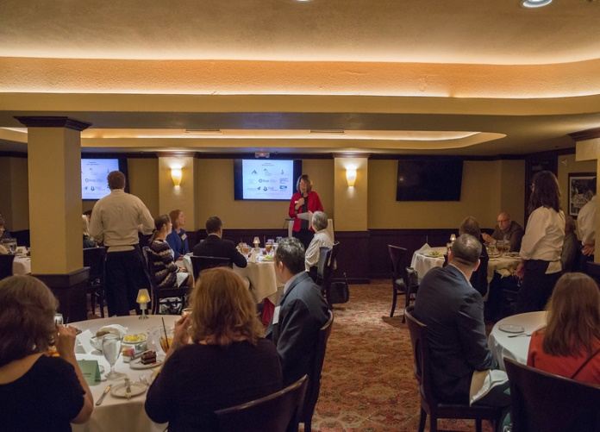

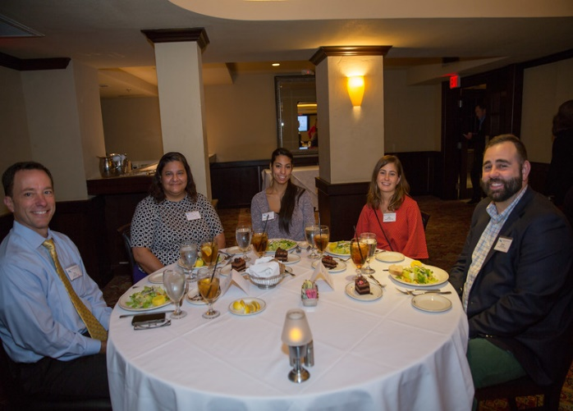

SPONSORSHIP OPPORTUNITIES
Engaging and educating our community at large about the impact of planned gifts on our city, our region, and our nation is the most important activity of the Charitable Gift Planners of Austin (CGPA). An affiliated chapter of the National Association of Charitable Gift Planners, CGPA membership is comprised of area trust officers, attorneys, CPA’s, planned giving officers, and senior development officers from local nonprofit institutions including secondary and higher education, private and community foundations, nonprofits supporting state agencies, religious denominations, arts and cultural organizations, and social service agencies. Members are seeking opportunities to further their knowledge of planned giving financial vehicles, taxation issues affecting charitable gifts, donor relationships, marketing planned gifts, and expanding their network of trusted colleagues and service providers. Chapter programs are credentialed for the CFRE Certified Fundraising Executive continuing education.
As a CGPA sponsor, your company or organization can provide financial resources that supports quality educational programming, a valuable resource not just for the professionals in our community but also for those looking to understand the intricacies of gift planning. Sponsorship also supports the chapter website and scholarships for the chapter’s leadership to attend the National Conference on Philanthropic Planning and leadership meetings. We invite you to consider sponsoring the activities of the Charitable Gift Planners of Austin.
CGPA Annual Chapter Sponsor $500
- Logo on CGPA website
- Logo on meeting announcement e-blasts
- Logo displayed at each luncheon meeting
- Opportunity to provide seat collateral at a luncheon meeting
- Complimentary attendance at one luncheon program by a company representative
- Introduction of company representative by Chapter President during meeting announcements
- Invitations to chapter mixers for up to two company representatives

SPONSORSHIP COMMITMENT
Yes! We wish to sponsor the educational activities of the Charitable Gift Planners of Austin. Please find our $500 Annual Chapter Sponsorship gift enclosed.

Company Name ____________________________________________________________________
Company Contact Name _____________________________________________________________
Company Contact Name’s Email Address ________________________________________________
Billing Address _____________________________________________________________________
City, State, Zip _____________________________________________________________________
Preferred Phone Number _____________________Preferred Fax Number ____________________
Company Web Site URL ______________________________________________________________

Payment Options:
Our check is enclosed. (Payable to the Charitable Gift Planners of Austin.)
Please charge to my credit card using the billing address above: Visa Mastercard

Name on Card _________________________________________________________

Credit card Number ______________________________ Expiration date _________

Signature ____________________________________________________________

Please return form with payment to: CGP of Austin PO Box 80401 Austin, Texas 78708 or via email to pgcct.atx@gmail.com if paying by credit card. Sponsorships may also be paid online at www.cgpaustin.org.
Please email company logo to: Megan Watkins, CGPA Director of Communications, at mnwatkins@ohkslaw.com.
Questions? Please contact CGPA President, Marcia Inger Navrátil at (512) 499-4320.

2020 Tentative Program Calendar

February 3, 2020

April 6, 2020

August 31, 2020

September 28, 2020

November 9, 2020

December 7, 2020

